Recovering and integrating lost parts of ourselves to become whole.
This workshop is an exploration from a Jungian perspective of the process as outlined in the writings of Marion Woodman, with workshop leaders
Josephine Dyer & Marilyn Copeland.
Dates: 14, 15, 16, 17, March and 16, 17, 18, 19 May 2024
Where: Oak Maree House, 5 McNamara’s Rd., Millgrove, Victoria 3799, Australia.

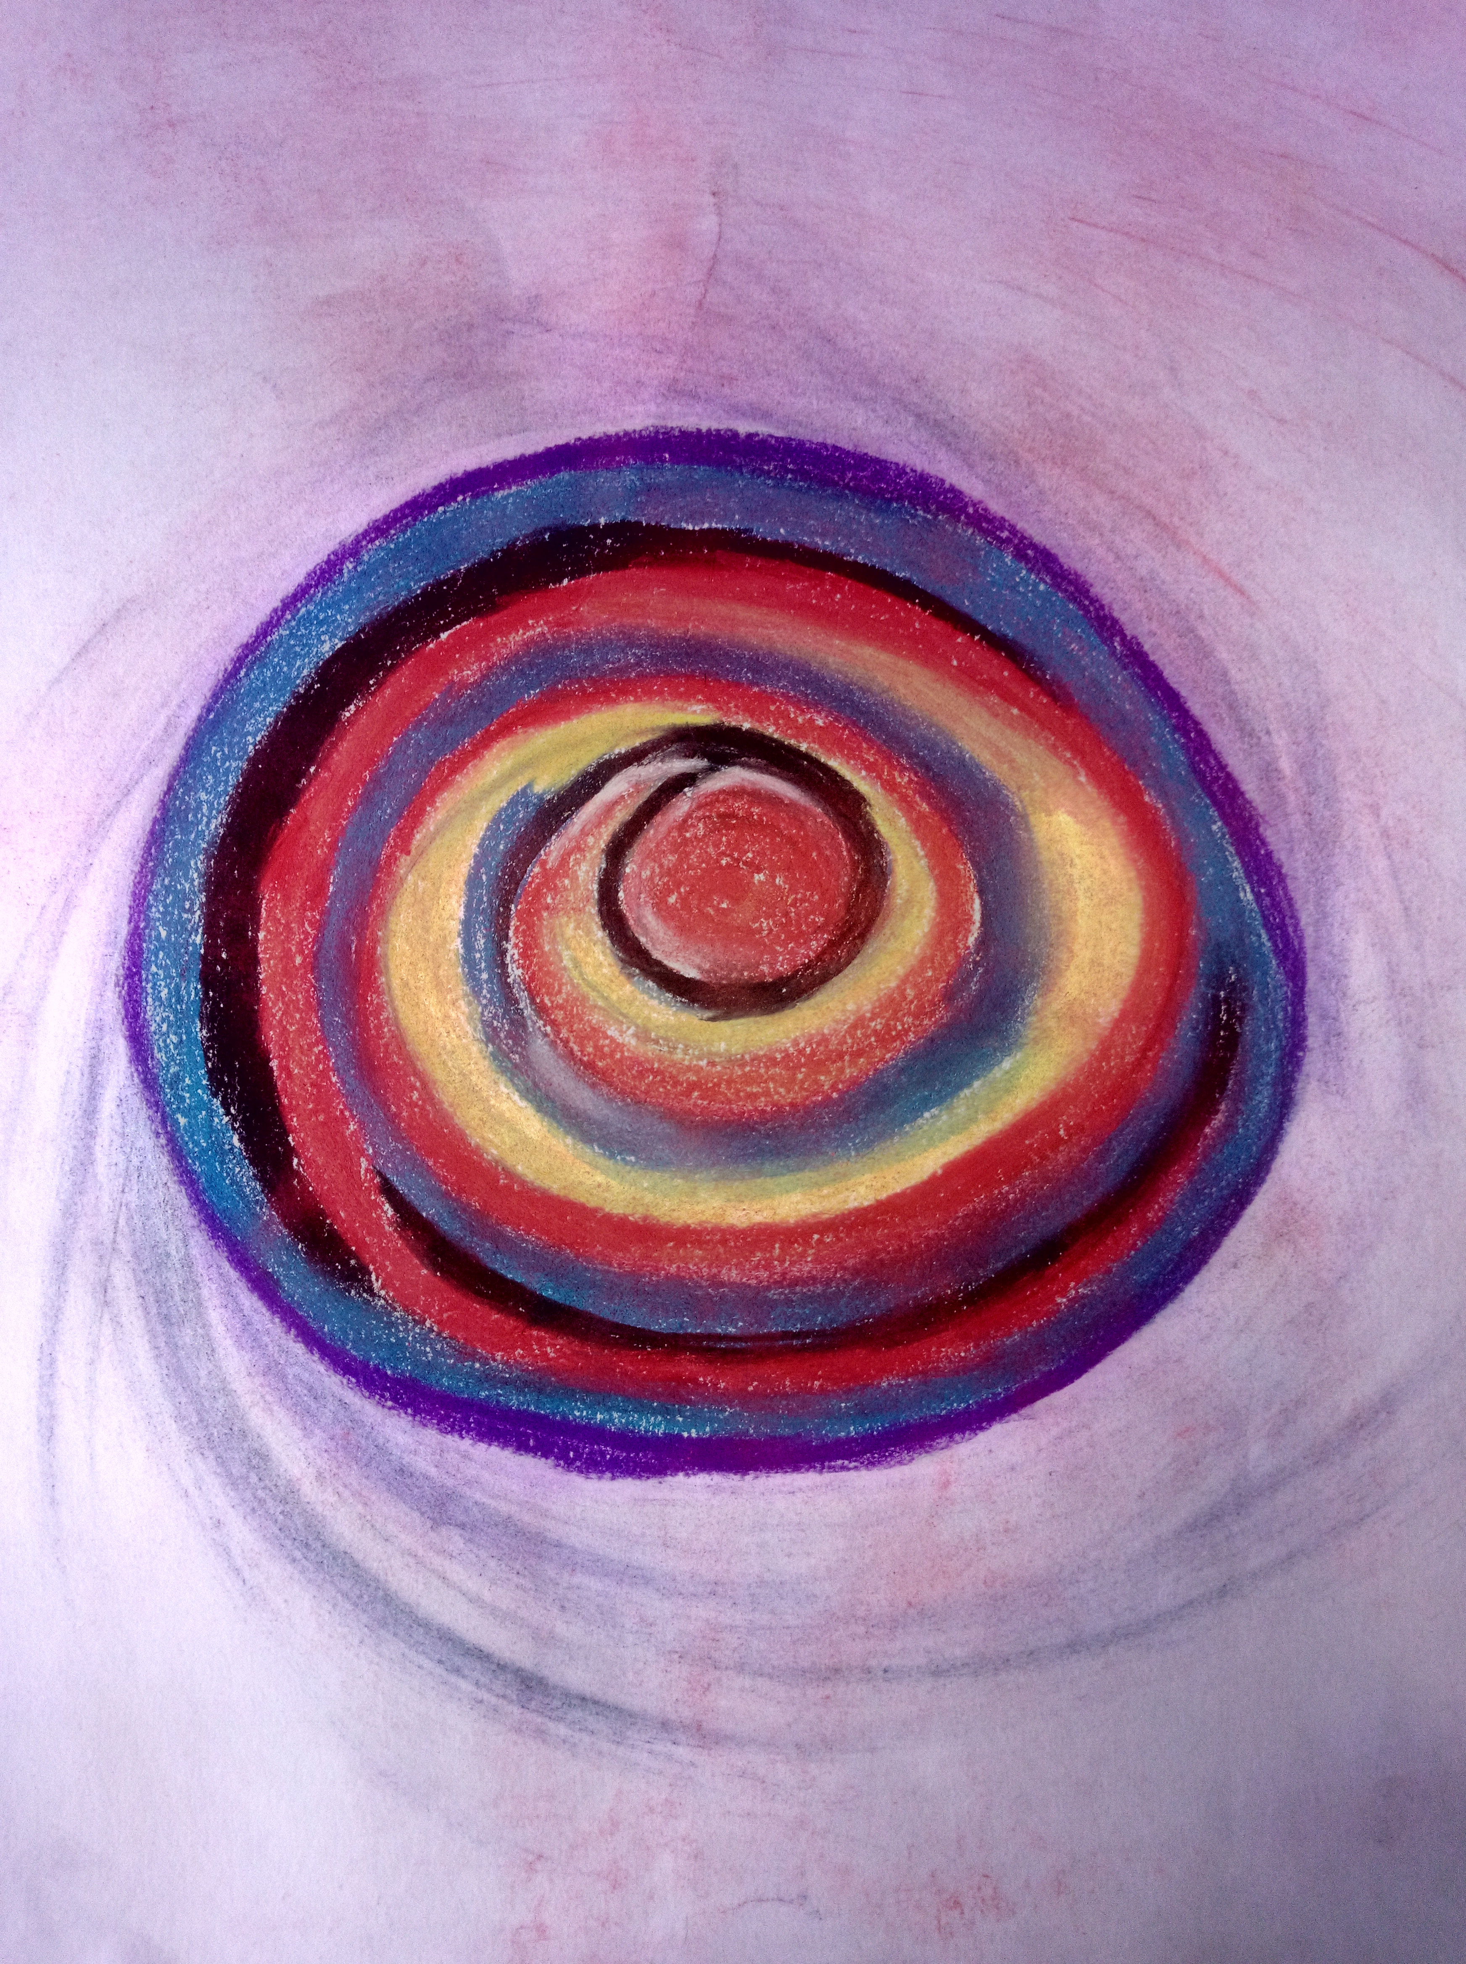

Many people have been fragmented and suffered losses through traumatic experiences.
In this workshop we will encourage you to reflect upon your life experiences and the dreams that come to guide you. There is space for you to explore your dreams through dance, art and music with others on the journey of Bodysoul Dreaming.

Through this workshop you may recover parts of yourself that you may have rejected or found too difficult to face in times of grief and loss. This process of discovery and integration can bring you healing and greater wholeness. ‘”The leap into freedom is the leap out of a powerdriven existence into a life lived in love. This is the leap from powerlessness into empowerment.” Marion Woodman

Workshop Leaders

Josephine Dyer is a Graduate of the Marion Woodman Foundation BodySoul Rhythms® Leadership Training with Body Soul Europe and has been leading the Body Soul Dreaming Community workshops in Australia with Joan Harcourt since 2013. She is committed to the BodyDreaming and the Treatment of Developmental Trauma process as outlined by Marian Dunlea in her book and the Training.

Marilyn Copeland brings a holistic approach to healing informed by her training in Dance Movement Therapy, Initiatic Art Therapy, Spiritual leaders Formation, and massage therapy. Her experience gives her a trust in the wisdom of the body and healing symbols that arise from the soul as guides to wholeness.
Suggested Background Reading:
Dunlea, Marian: BodyDreaming and the Treatment of Developmental Trauma.
Woodman, Marion: The Pregnant Virgin and The Ravaged Bridegroom
Sitting by the Well with Marion Woodman. www.mwoodmanfoundation.org
For further information on workshops check the Marion Woodman Foundation Website:

Workshop Dates:
14, 15, 16, 17 March and 16, 17, 18, 19 May 2024
Please note booking is essential for these workshops and payment is required in advance.

Workshop Fees: 1 X $600 Includes Accommodation, Meals,
Morning & Afternoon Tea.
Applications & payment need to be made no later than 1st March 2024
to Bendigo Bank: Account: BSB 633-000 No: 147 415 509 Account Name: J. M. Dyer Body Dreaming

For more information and an application form
contact: Josephine Dyer on 0408 370 217 or email josephinedyer2@gmail.com

